**COMPUTER SCIENCE DEPARTMENT**

Computer Organization and Assembly Language

**Lab Task # 11**

**Last date of Submission: 21th May 2024**

# Submitted To: Sir Ahmed Saleem

**Student Name: UBAID-BIN-WARIS**

# Reg. Number: 2212416

# 

**Question no. 01**

Consider you have an array containing 5 numbers. You can declare the array as:  num_array db 2d, 5d, 4d, 9d, 3d .Find out the first number that is greater is 7.

**Code**

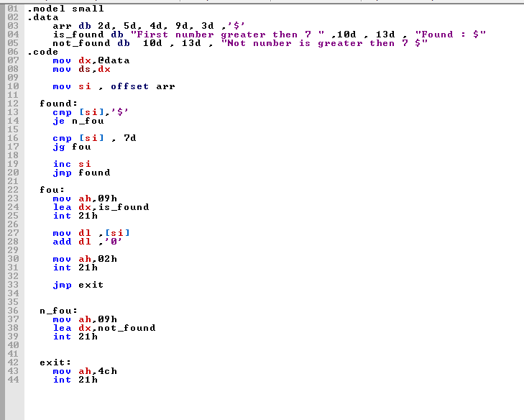

**Output**

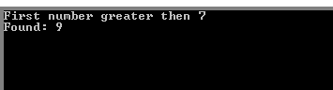

**Question no. 02**

an assembly language program to count the number of zeros in the contents of register BX.

**Code**

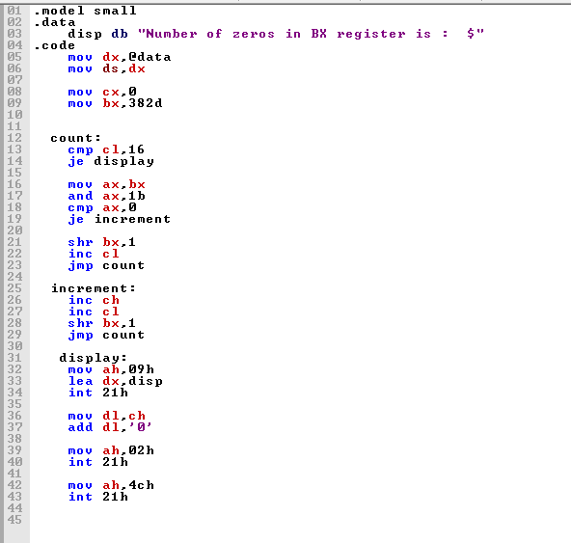

**Output**





